**UT – IT _PLAN REPORT**

TR_01 : main()

User enters the functions, according to his choice.

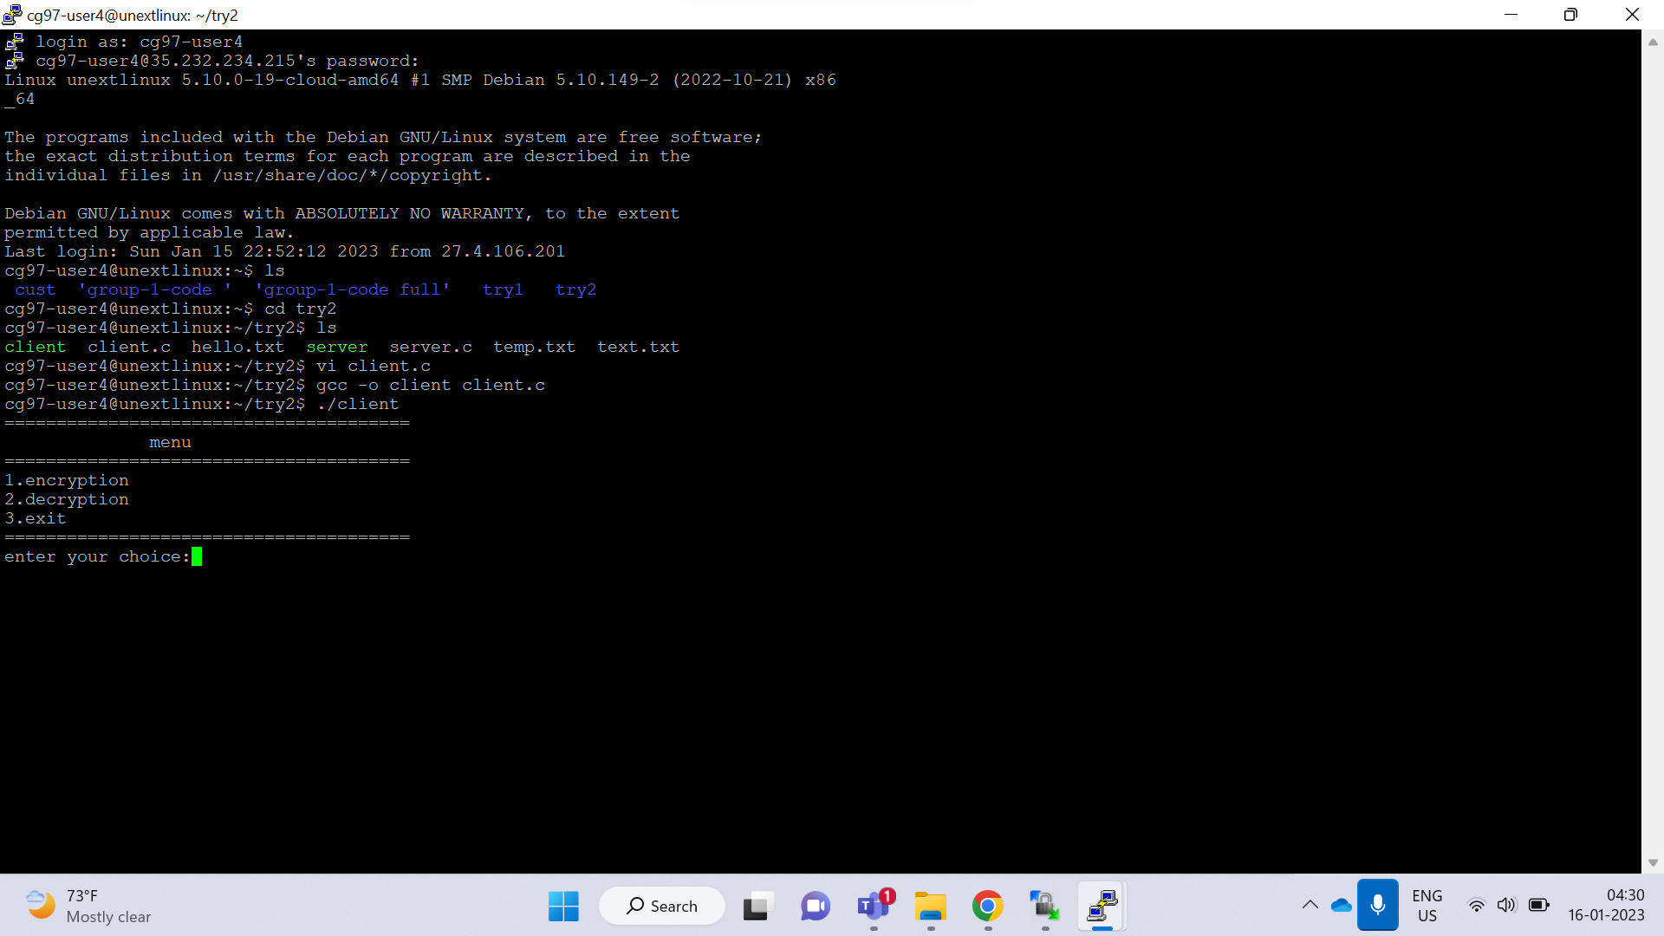

TR_02 : main()

User enters invalid choice

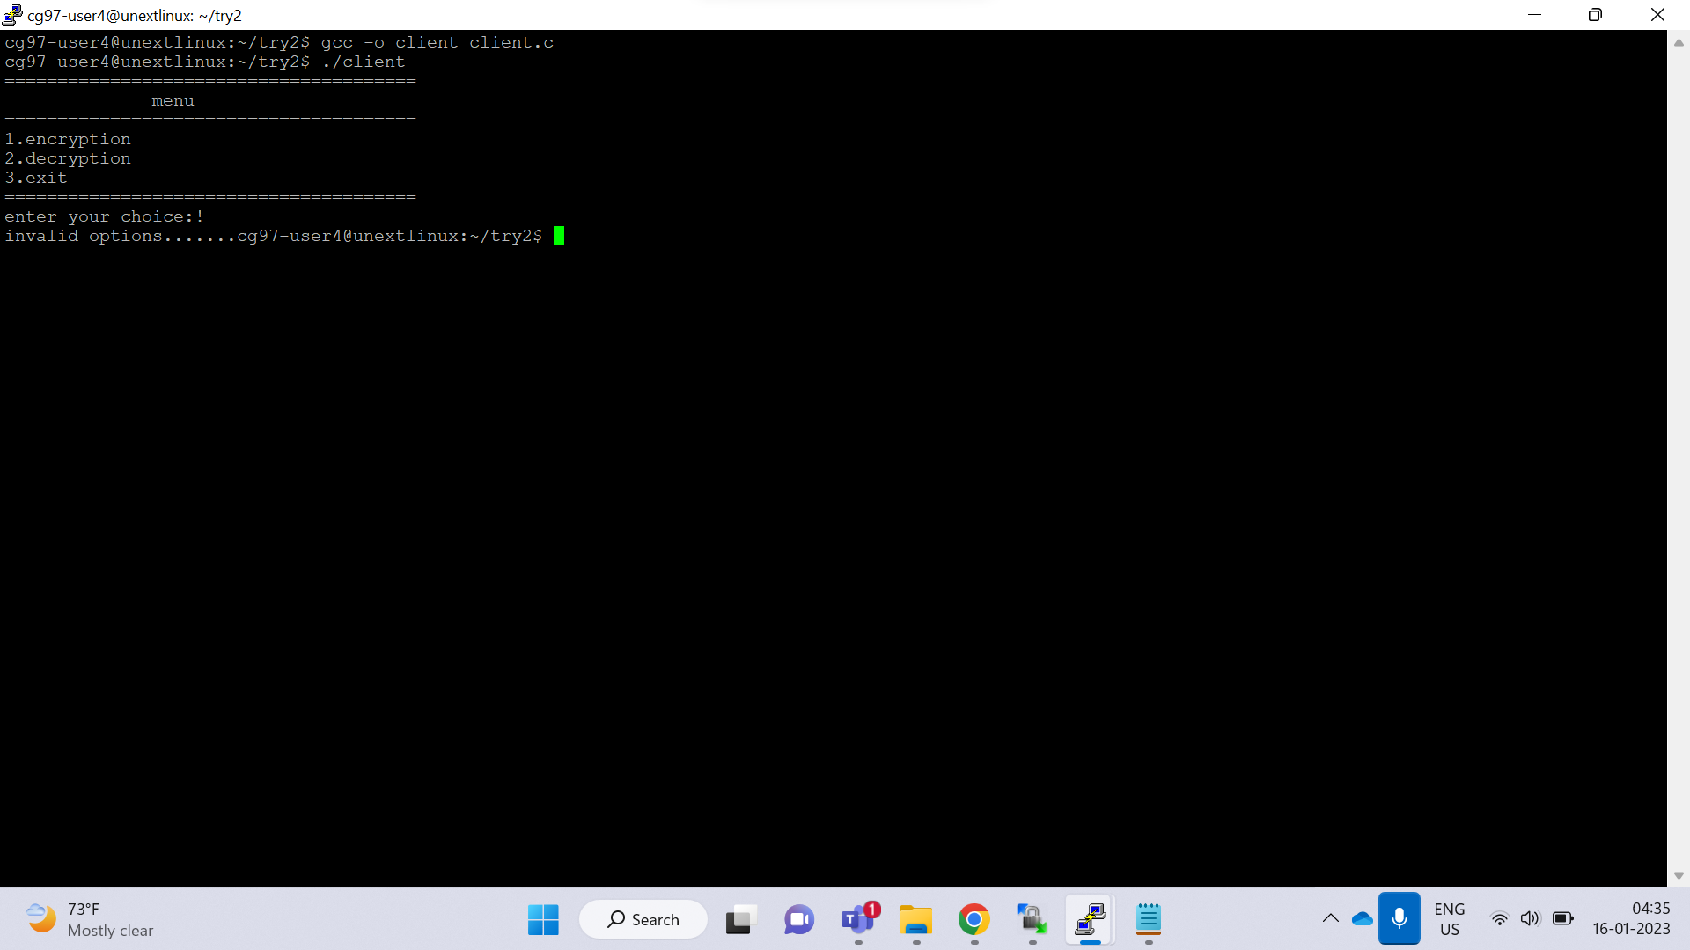

TR_03: main()

User enters invalid choice

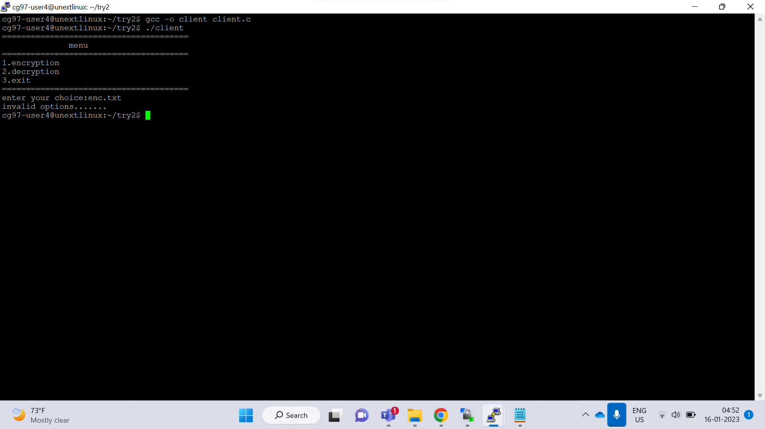

TR_04 : encryption()

User enters option according to his choice

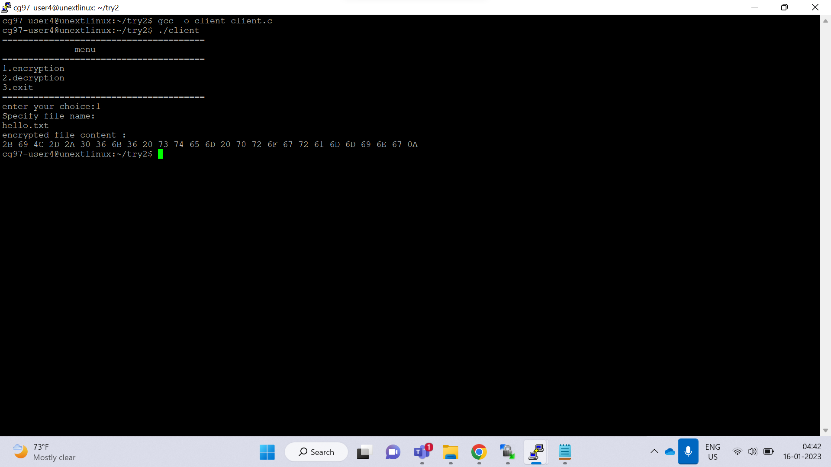

TR_05 : encryption()

User enters invalid option according to his choice

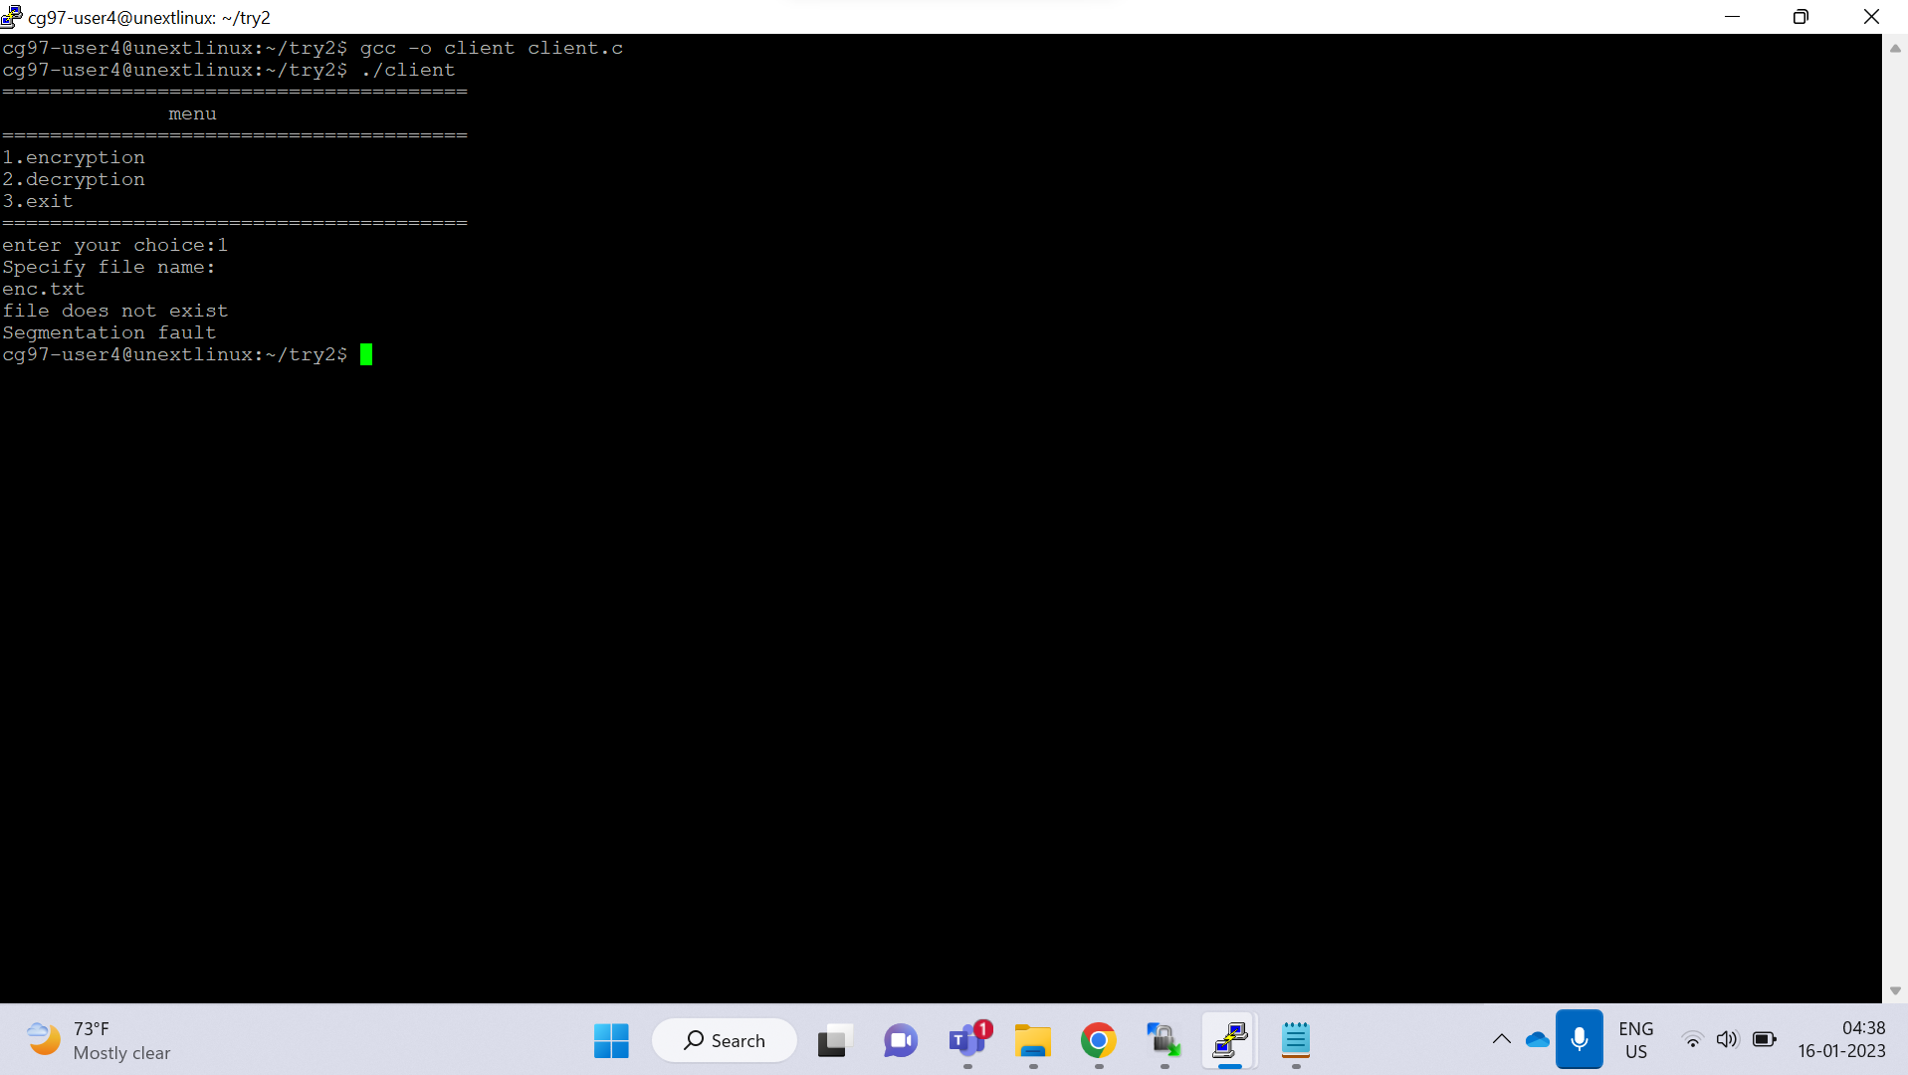

TR_06 : encryption()

User enters invalid option according to his choice



TR_07 : encryption()

User enters invalid option according to his choice

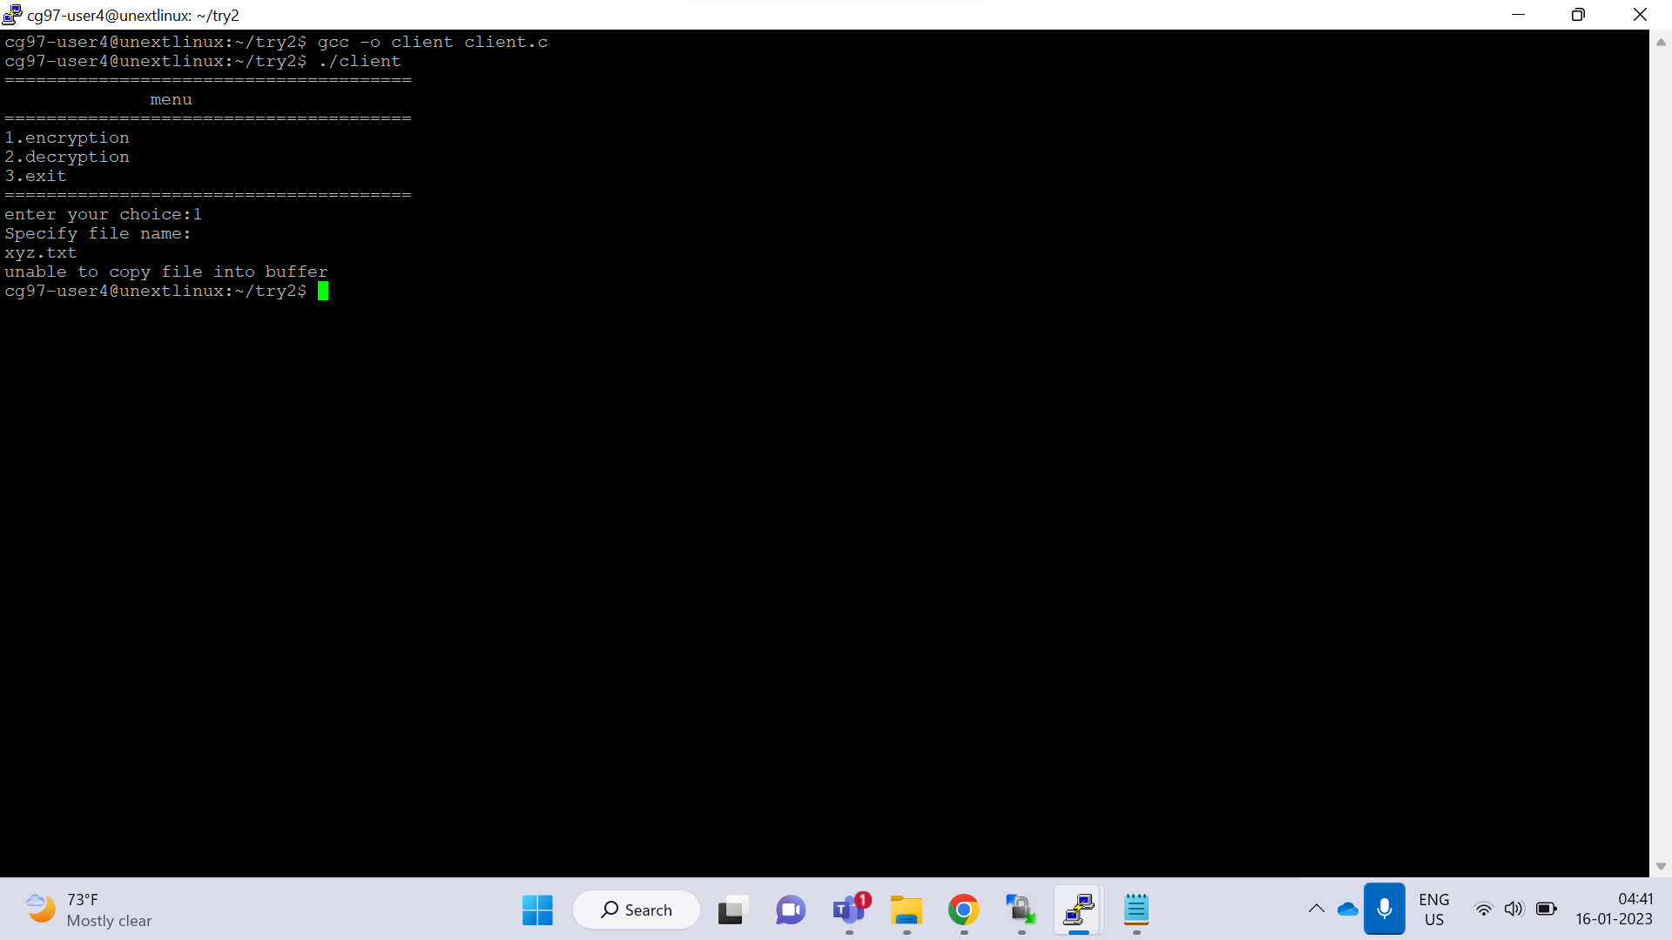

TR_08 : encryption()

User enters invalid option according to his choice

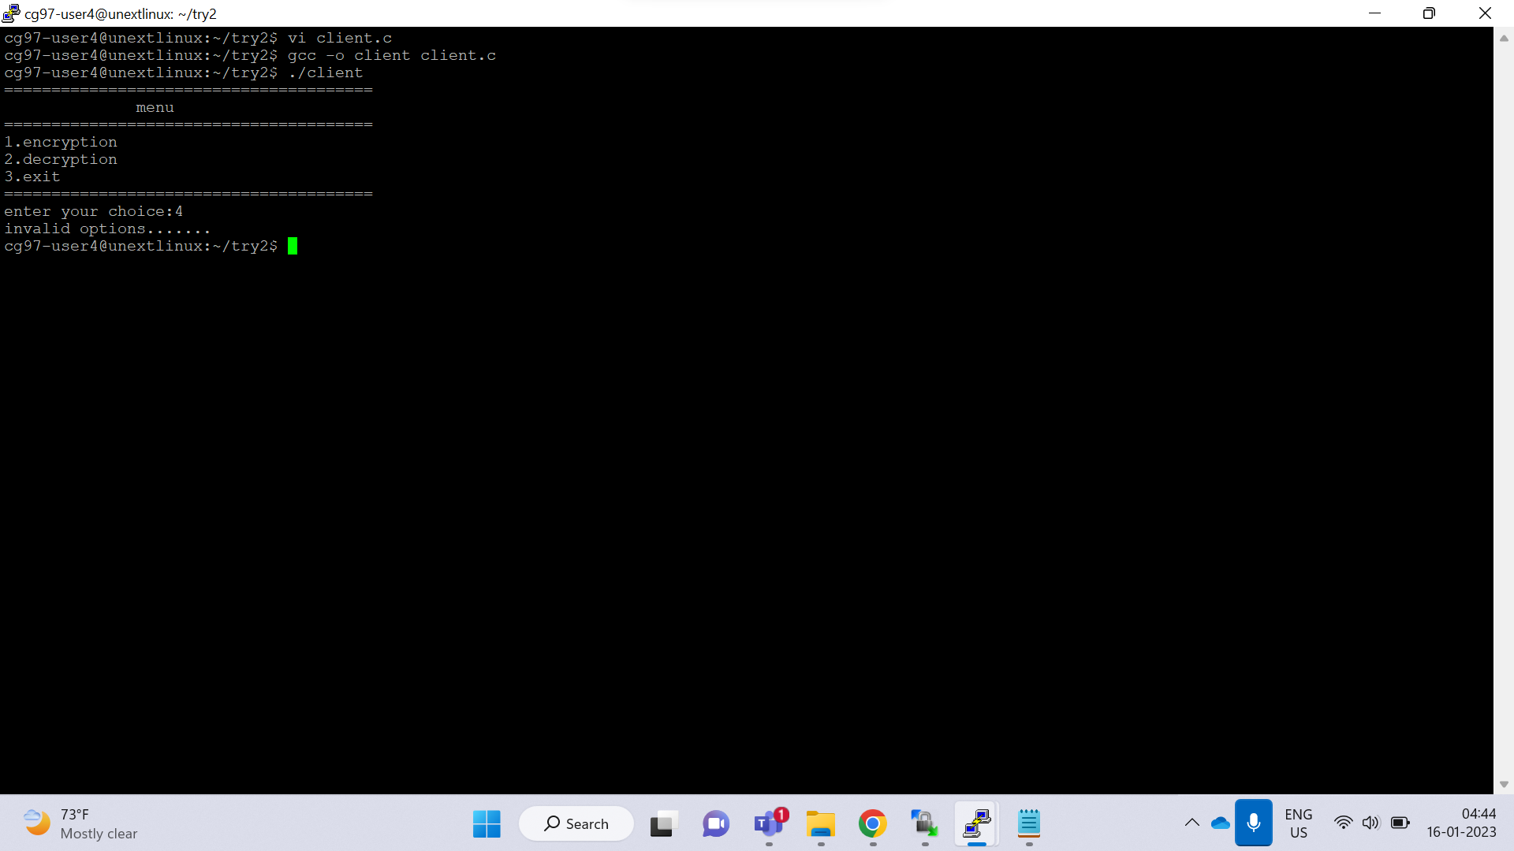

TR_09: decryption()

User enters valid option according to his choice

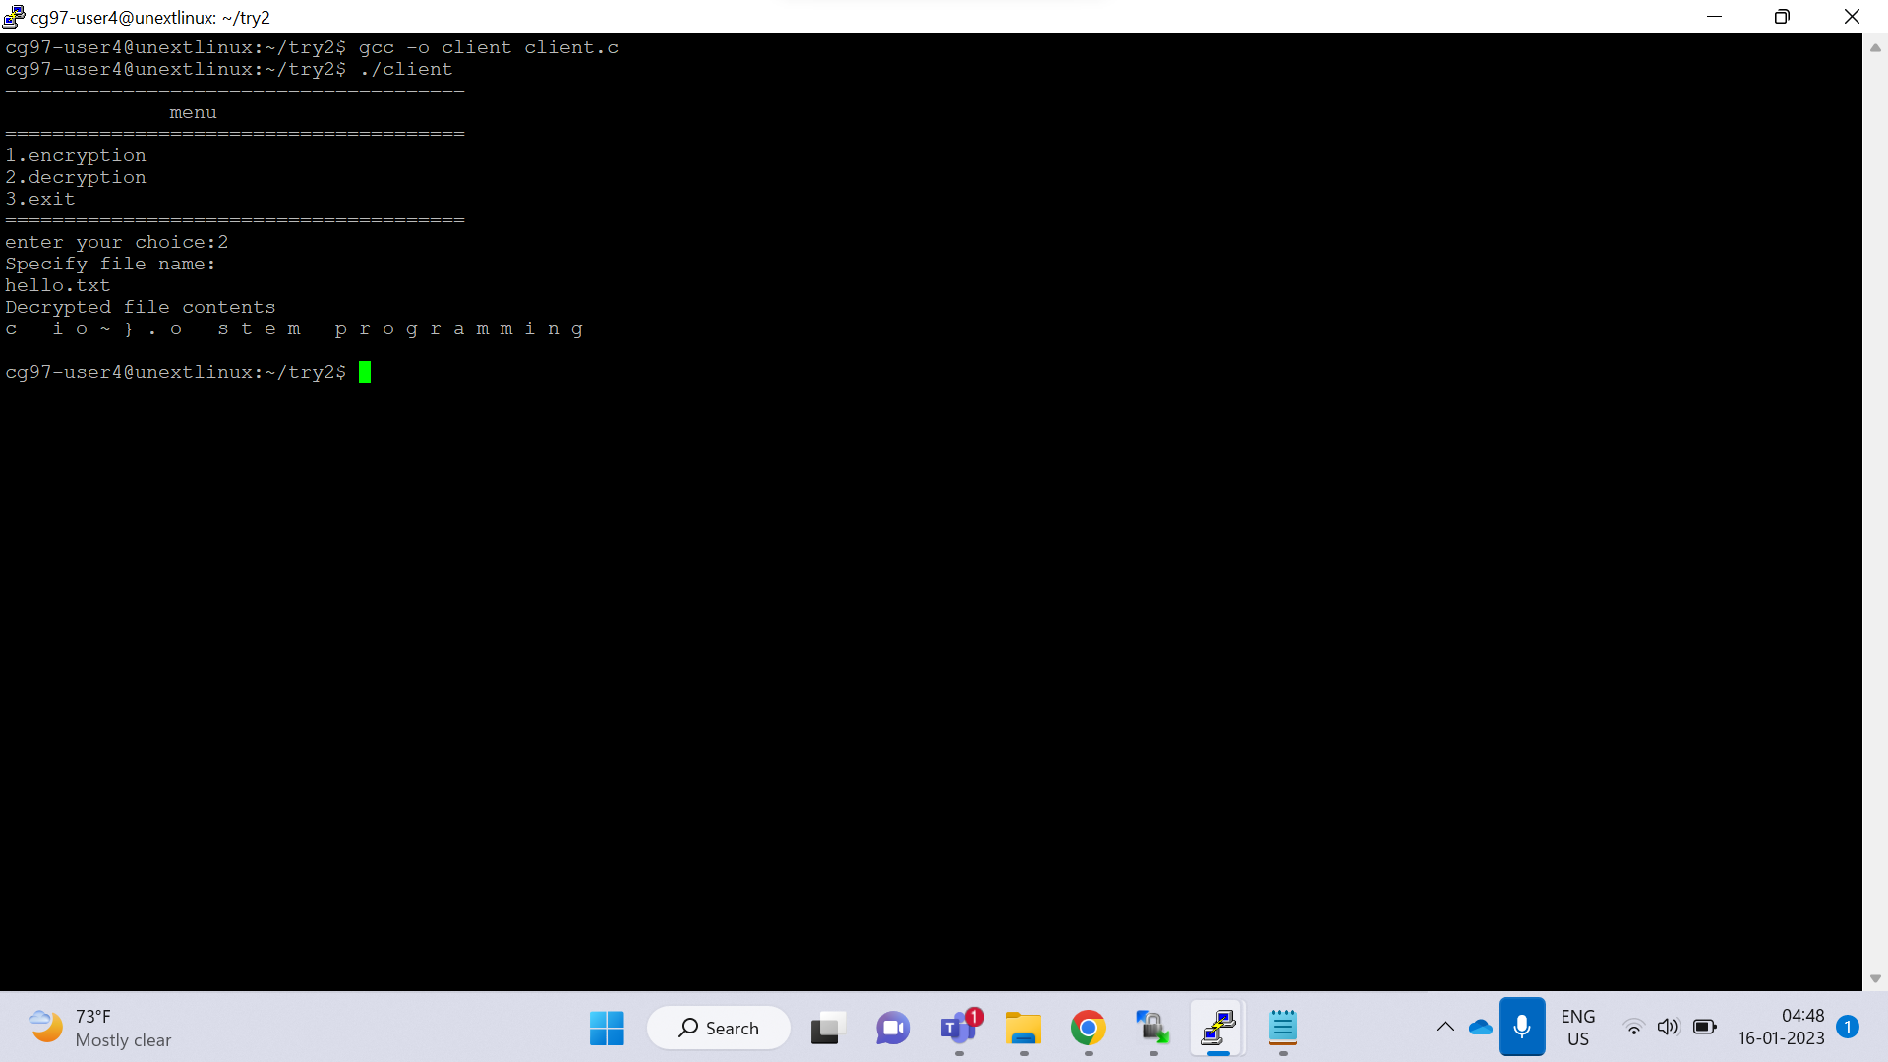

TR_010: decryption()

User enters invalid option according to his choice

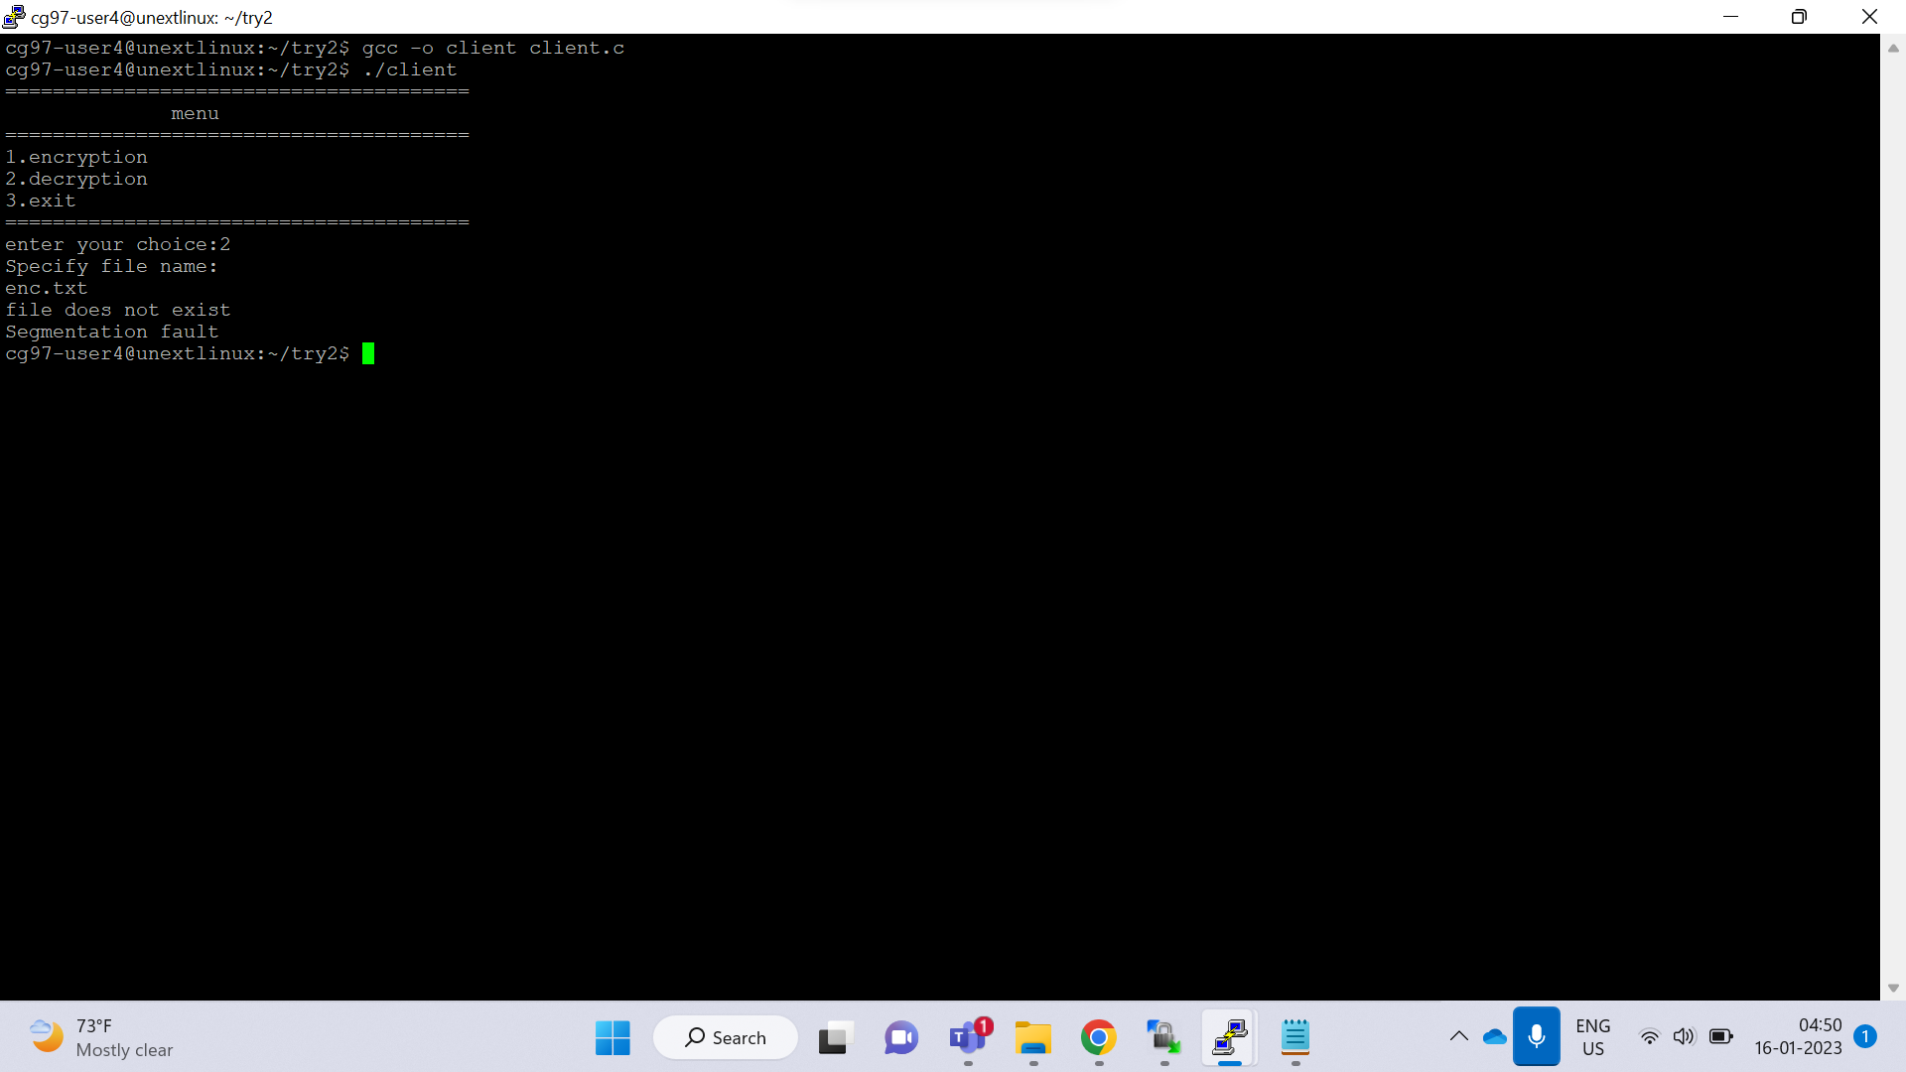

TR_011: decryption()

User enters invalid option according to his choice

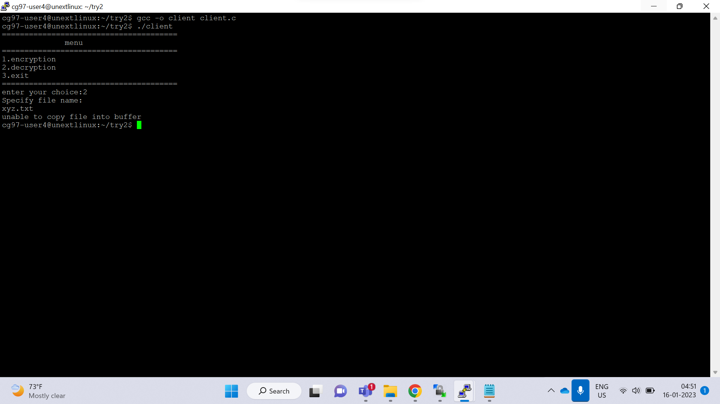

TR_12: server()

Server waiting for client

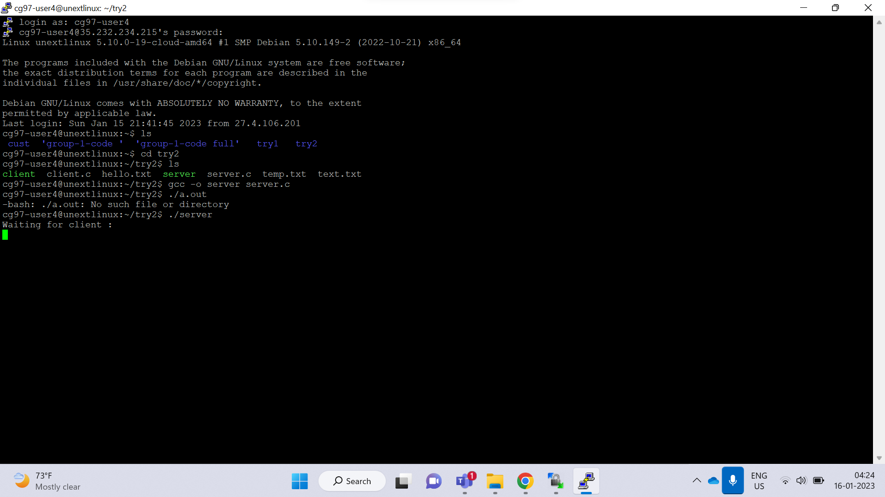

TR_13: server()

Server after establishment

